STOP

the spread

REDUCE THE RISK OF COVID-19

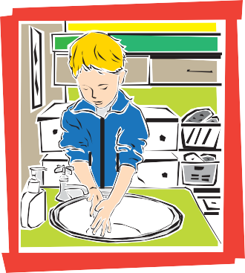Wash your hands often with soap and running water.

Avoid close contact with people who are sick.

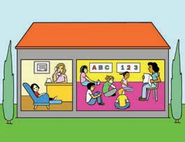

Open windows for fresh air.

Avoid touching your eyes, nose or mouth.

Stay home from work, school and public places when you are sick.

Cover your mouth and nose when coughing or sneezing.

Cough and sneeze into your sleeve

or use a tissue.

Practice good health habits. Eat nutritious food, exercise, and get

plenty of sleep.

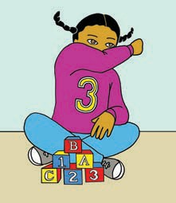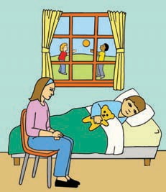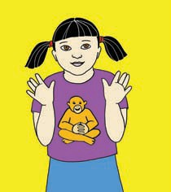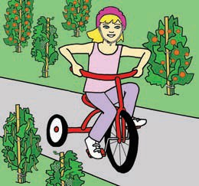

3/20

California Childcare Health Program

**cchp.ucsf.edu**